**Promoting Goods/Services via DIMI3’s online platforms**

Product placements have gained immense popularity in recent times, Music videos are a highly efficient means of targeting adolescent audiences, particularly within the pop, rap and RnB genres. They offer lucrative opportunities for brands to be marketed to this growing consumer segment. This ties into influencer marketing which is now considered to be more trustworthy by the adolescent consumer as they consider influencers among their peers.

**Product placement and promotions**

**How product placement benefits and helps promote DIMI3 as a brand**

**Current Standings on Social Media**



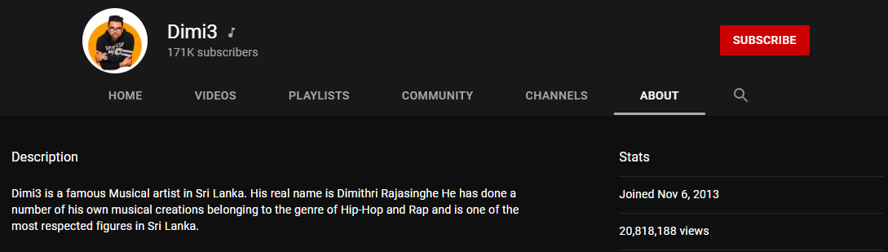

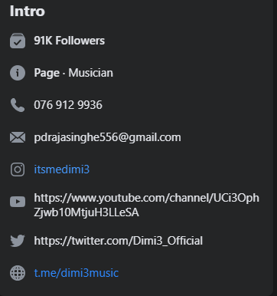 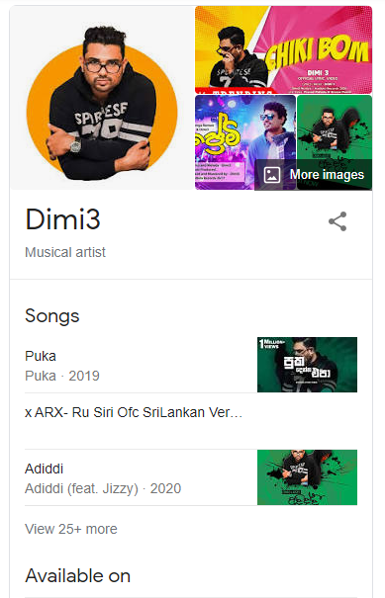

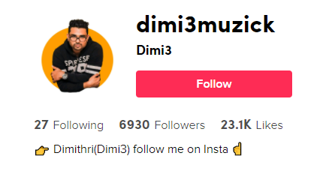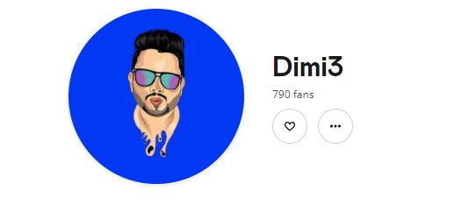

 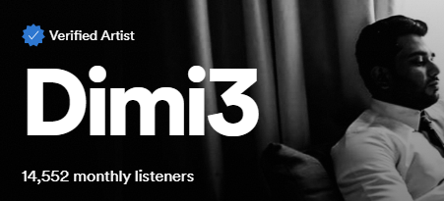 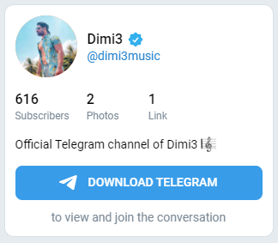

Subtlety is key as can be seen in the opening scenes of Nirvana’s “[Smells Like Teen Spirit](https://youtu.be/hTWKbfoikeg)”, the video begins with a band member tapping his foot wearing Converse shoes, this is one of the older examples of this technique but is noticeable enough and is executed flawlessly in an artful manner.

What should be avoided is the blatant attempt to promote a product/service to the extent where a music video instead appears to be one long winding advert. Such is the case for David Guetta’s “[Alphabeat](https://youtu.be/vzE8d5AXImo)” which comes off as an elongated advert for the Renault Twizy EV.

**Outline**

1. Introduction
2. Statistics and deliverables
   1. the media exposure and ROI we can give in a short, logical breakdown
   2. Mention followers and views online
   3. how our target audience and sponsors target audience overlap
3. How we will show the ROI, sales leads and engagement that we generate
   1. Unique sponsor codes to measure feedback
   2. individual landing page to drive traffic
   3. Brand exposure (to be discussed)
4. Highlight something unique that DIMI3 can offer
   1. e.g.- new brand image, different audience (to be discussed)